Static and Kinetic Friction Lab
Tommy Wang

Preliminary Questions
1. The force to start the box moving is greater than the force to keep it moving. I'm basing this on pushing heavy furniture. It takes a hard shove to get it going, and then it is easier to keep it sliding.
2. I think friction gets bigger when the box is heavier, and that it goes up in proportion to the weight. A heavier box pushes down on the floor harder, so the surfaces are pressed together more.

Data Tables
Part I: mass of block = 0.462 kg
Part II: Peak static friction
Total mass (kg) | Normal force (N) | Trial 1 (N) | Trial 2 (N) | Trial 3 (N) | Average (N)
0.962 | 9.428 | 4.847 | 4.627 | 4.847 | 4.774
1.462 | 14.33 | 6.718 | 6.846 | 6.092 | 6.552
1.962 | 19.23 | 11.65 | 10.77 | 11.30 | 11.24

Part II: Kinetic friction
Total mass (kg) | Normal force (N) | Trial 1 (N) | Trial 2 (N) | Trial 3 (N) | Average (N)
0.962 | 9.428 | 4.193 | 4.192 | 4.080 | 4.155
1.462 | 14.33 | 6.147 | 5.862 | 5.727 | 5.912
1.962 | 19.23 | 6.706 | 6.537 | 6.415 | 6.553

Part III: Block with no additional mass (m = 0.462 kg)
Trial | Acceleration (m/s²) | Kinetic friction force (N) | μk
1 | 4.136 | 1.911 | 0.422
2 | 3.987 | 1.842 | 0.407
3 | 4.000 | 1.848 | 0.408
 |  | Average μk: | 0.412

Part III: Block with 500 g additional mass (m = 0.962 kg)
Trial | Acceleration (m/s²) | Kinetic friction force (N) | μk
1 | 4.094 | 3.938 | 0.418
2 | 4.355 | 4.190 | 0.444
3 | 4.329 | 4.164 | 0.442
 |  | Average μk: | 0.435

Analysis
1. Labeled force vs. time graph (500 g added, trial 1):
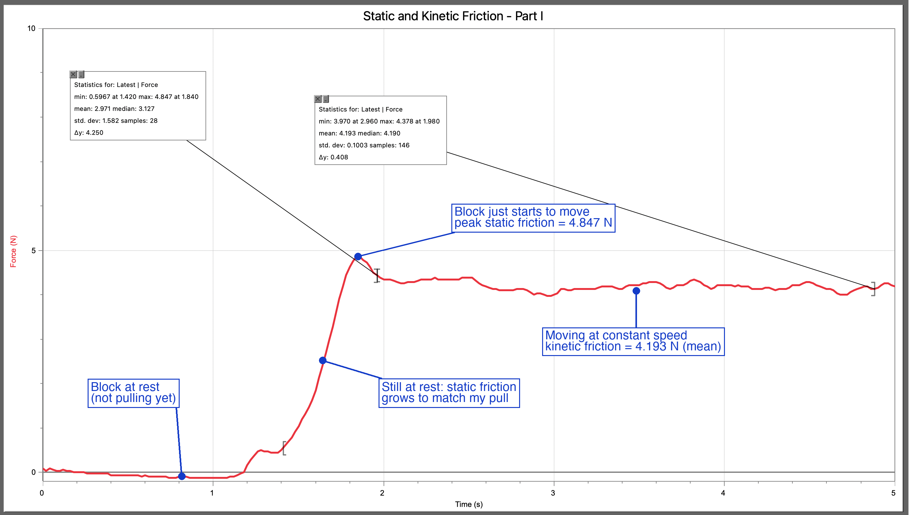
The block is at rest from 0 s until the peak at 1.84 s. I start pulling at about 1.2 s, and the force climbs while the block still doesn't move. The block just starts to move at the peak, 4.847 N at 1.84 s. After that it moves at constant speed from about 1.96 s to 4.88 s, where the force is flat at 4.193 N.
2. It took 4.847 N to start the block sliding but only 4.193 N to keep it sliding, so starting takes more force. This matches my experience. A heavy box on the floor is hardest to push right at the start, and once it breaks loose it is easier to keep going.
3. Greater than. With the same normal force, the peak static friction (4.847 N) was bigger than the kinetic friction (4.193 N). Since the coefficient is friction divided by normal force, the static coefficient has to be bigger too.
4. The table is horizontal, so the normal force equals the weight, N = mg. 0.962 kg × 9.8 = 9.428 N. 1.462 kg × 9.8 = 14.33 N. 1.962 kg × 9.8 = 19.23 N. These are filled in for both Part II tables.
5. Maximum static friction vs. normal force:
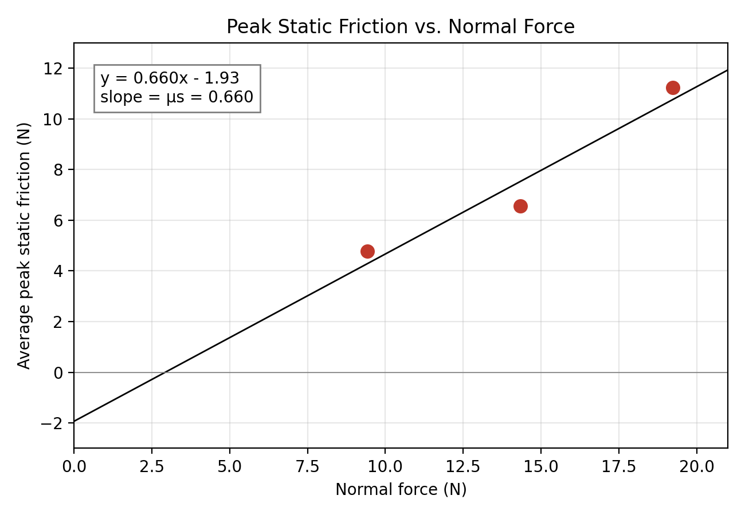
6. The slope is 0.660, so μs = 0.660. It has no units, because it is newtons divided by newtons. In theory the line should pass through the origin, because F = μs·N means zero normal force gives zero friction. My best-fit line is y = 0.660x − 1.93, so it misses the origin by 1.93 N. I only have three points and they don't sit on one straight line. The peak depends on how smoothly I pulled, and at 1.462 kg my three peaks went from 6.092 N to 6.846 N.
7. Average kinetic friction vs. normal force:
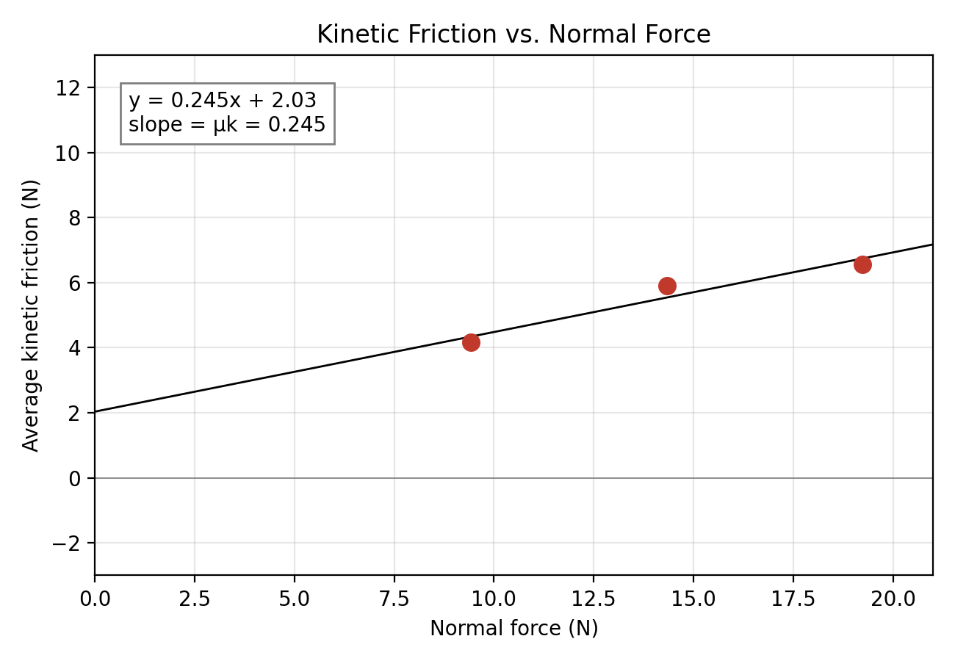
The slope is 0.245, so μk = 0.245 from this graph. It should pass through the origin for the same reason as before: F = μk·N, so no normal force means no friction. My line is y = 0.245x + 2.03, so it does not. It crosses the y-axis at 2.03 N. The kinetic friction went up with normal force, but not in proportion. Dividing each average by its normal force gives 0.441, 0.413 and 0.341, so the heaviest run came out low and that flattens the slope.
8. Free-body diagram for the sliding block:
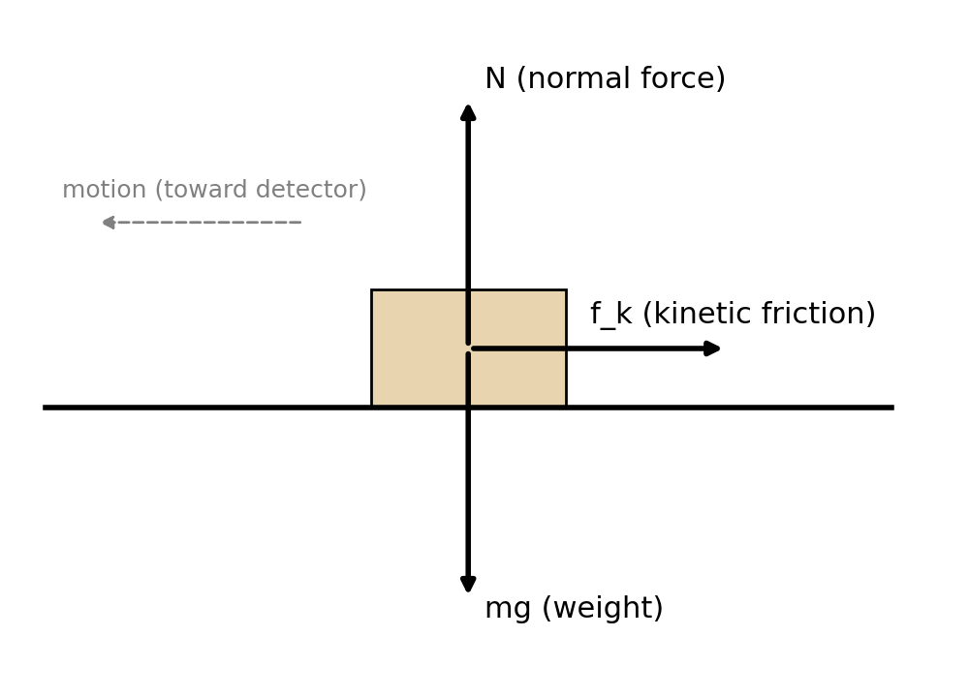
After the block leaves my hand, friction is the only horizontal force, so f_k = ma. Vertically, N = mg. Example for trial 1 with no added mass: f_k = 0.462 × 4.136 = 1.911 N. The other trials are in the data table.
Sample velocity vs. time graph (no added mass, trial 1). The shaded part is the section I used for the acceleration:
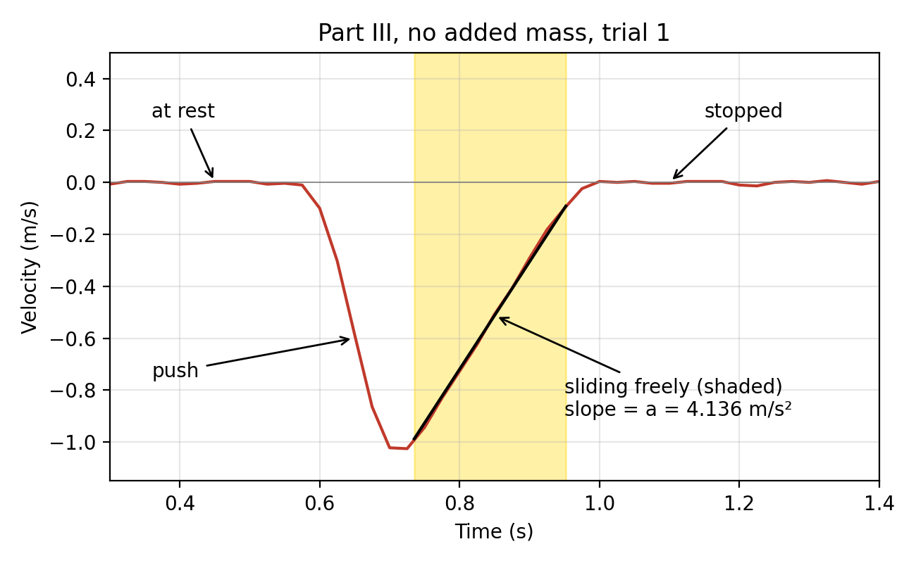
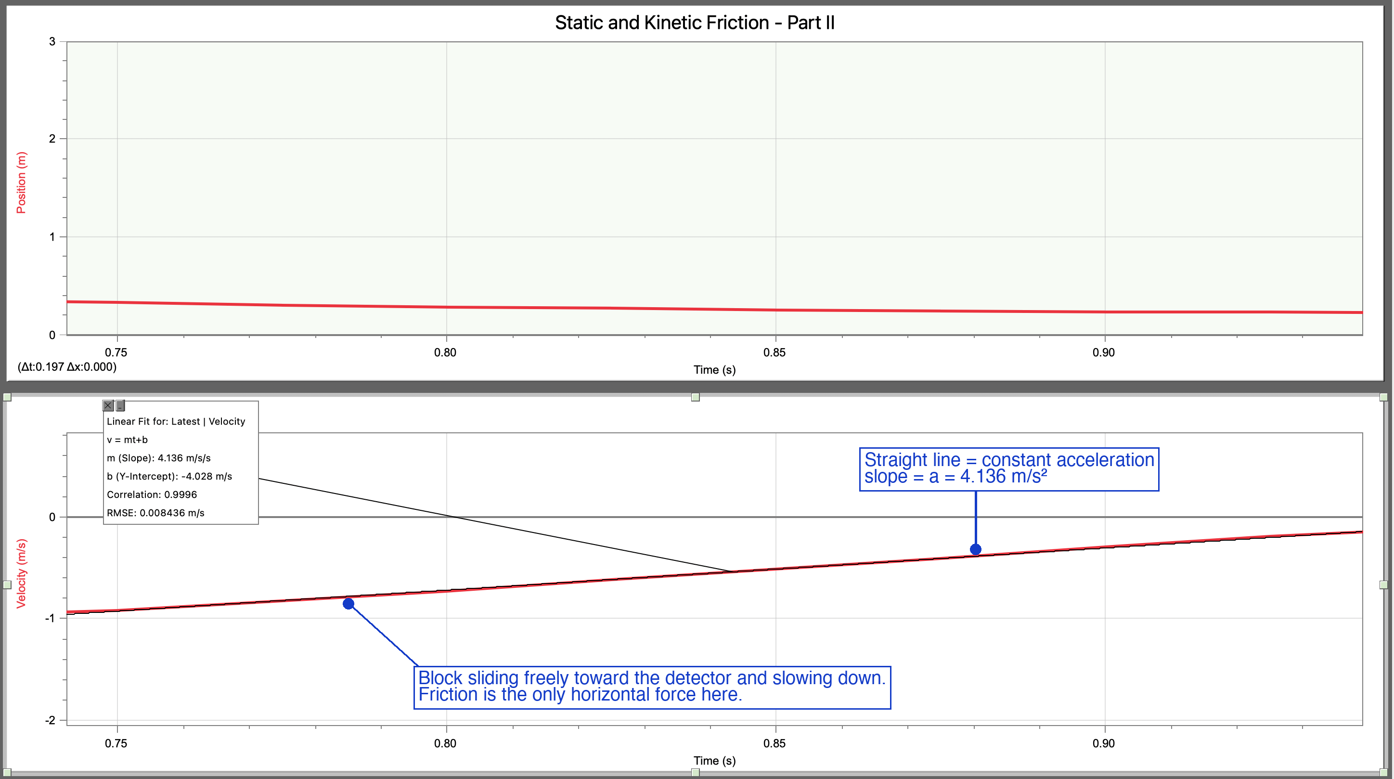
Logger Pro's linear fit on that section gives a slope of 4.136 m/s², with correlation 0.9996.
9. μk = f_k / N = ma / mg = a / g. Example: 4.136 / 9.8 = 0.422. The average is 0.412 for the block alone and 0.435 for the block with 500 g. All six values are in the data table.
10. No. In the trial 1 graph the block slowed from about 1.0 m/s to about 0.1 m/s, and the velocity graph stayed a straight line the whole way (correlation 0.9996). A straight line means the acceleration was constant, so the friction force was the same at high speed and at low speed. If μk depended on speed the line would curve.
11. Yes. In Part II the average kinetic friction went from 4.155 N to 5.912 N to 6.553 N as the normal force went from 9.428 N to 14.33 N to 19.23 N. In Part III the average friction force was 1.867 N for the block alone and 4.097 N with 500 g added. More weight gave more friction every time.
12. Not really. In Part III the weight more than doubled (0.462 kg to 0.962 kg) but μk only went from 0.412 to 0.435, about 5% different. In Part II, friction divided by normal force was 0.441, 0.413 and 0.341. The first two agree with Part III. The heaviest one is lower, but I think that is from pulling by hand and not a real change, since Part III doesn't show μk going down with weight.
13. Part III gave μk = 0.412 (block alone) and 0.435 (with 500 g). Part II gave μk = 0.245 from the slope. I expected them to be the same, because it is the same block on the same surface and μk only depends on the two surfaces. They are not the same. The Part II slope is small because the best-fit line has a 2.03 N intercept and doesn't go through the origin. If I use friction divided by normal force for each Part II mass, I get 0.441 and 0.413 for the two lighter loads, which do agree with Part III. I trust Part III more, because the acceleration comes from the motion detector and a linear fit, while Part II depends on me pulling at a steady speed by hand.

Extension
1. On an incline the block starts to slide when mg·sinθ = μs·mg·cosθ, so tanθ = μs. With μs = 0.660, θ = arctan(0.660) = 33.4°. If the angle was measured 2° off, I would get μs = tan(31.4°) = 0.611 or tan(35.4°) = 0.711. So the coefficient would change by about 0.05, which is about 8%.

